App Dev Project Report

1. Student Details
Name: P Bernice Cynthia
Roll Number: 24f2009111
Email: 24f2009111@ds.study.iitm.ac.in
About Me: I am a student in the IIT Madras BS Degree program with a strong interest in web application development and full-stack technologies. I enjoy creating efficient, user-centric solutions that integrate databases, authentication, and responsive design to address practical challenges like campus management systems.

2. Project Details

Project Title: Placement Portal Application

Problem Statement: Placement portals are critical for managing campus recruitment activities. Traditional systems using spreadsheets and emails are inefficient for managing company registrations and approvals, student applications and tracking, placement drive management, and avoiding duplicate registrations.

Approach: The app was built using Flask as the backend framework with a modular structure. It allows admin to approve companies and drives, companies to create drives and manage applications, and students to apply for approved drives, view status, and access history.

3. AI/LLM Declaration
I used GitHub Copilot for code suggestions and formatting – extent around 20%. All logic was manually implemented.

4. Technologies and Frameworks Used
Technology / Library | Purpose
Flask | Core backend web framework
SQLAlchemy | Object Relational Mapper for SQLite database
Jinja2 | Template engine for rendering dynamic HTML pages
Bootstrap 5 | Frontend styling and responsive design
Flask-Login | User authentication and session management
WTForms | Form validation and rendering
SQLite | Lightweight local database for storing user data

5. Database Schema / ER Diagram
Tables:
- User — stores user profile details (id, username, email, password, role, is_active)
- StudentProfile — stores student-specific information (id, user_id, name, contact, resume_path)
- CompanyProfile — stores company details (id, user_id, name, hr_contact, website, approval_status)
- PlacementDrive — manages job postings (id, company_id, job_title, job_description, eligibility, deadline, status)
- Application — tracks student applications (id, student_id, drive_id, application_date, status)
Relationship:
- One-to-One: User → StudentProfile
- One-to-One: User → CompanyProfile
- One-to-Many: CompanyProfile → PlacementDrive
- One-to-Many: StudentProfile → Application
- Many-to-One: Application → PlacementDrive
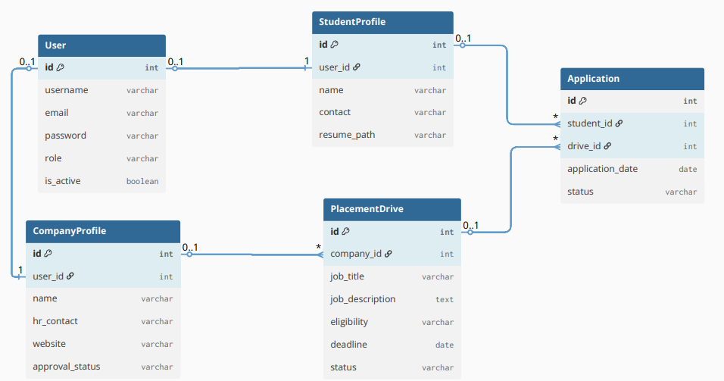

6. API Resource Endpoints
Endpoint | Method | Description
/login | GET / POST | User login
/register/company | GET / POST | Company registration
/register/student | GET / POST | Student registration
/admin/dashboard | GET | Admin dashboard
/company/dashboard | GET | Company dashboard
/student/dashboard | GET | Student dashboard
/company/create-drive | GET / POST | Create placement drive
/student/apply/<drive_id> | GET / POST | Apply for drive

7. Architecture and Features

Architecture Overview:

app.py – main Flask application entry point

models.py – database models using SQLAlchemy

routes/ – Flask Blueprints for authentication, admin, company, and student routes

templates/ – Jinja2 HTML templates organized by role

static/ – CSS and Bootstrap styling files

Implemented Features:
- User registration and login for all roles
- Admin approval for companies and drives
- Company drive creation and management
- Student application and status tracking
- Search functionality for admin
- Responsive UI built with Bootstrap
- Secure password hashing and session handling
Additional Features:
- Prevent duplicate applications
- Role-based access control
- Flash messages for user feedback
- Profile management with resume upload

8. Video Presentation
Drive Link:
https://drive.google.com/file/d/105y3GUVslLXYwYbJWv0WdIWLQOGYBHFM/view?usp=sharing

